Leukemia Data set: Pareto front on train (Gen. 50)

4

Leukemia Dataset: Pareto front on train (Gen. 100)

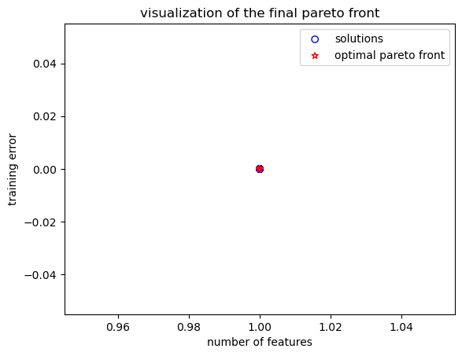

Colon Dataset: Pareto front on train (Gen. 40)

Colon Dataset: Pareto front on train (Gen. 100)

